(Semester II)

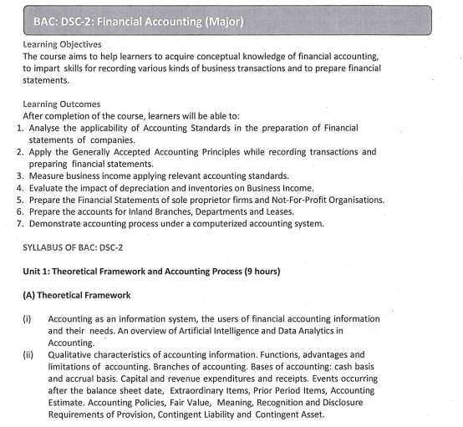

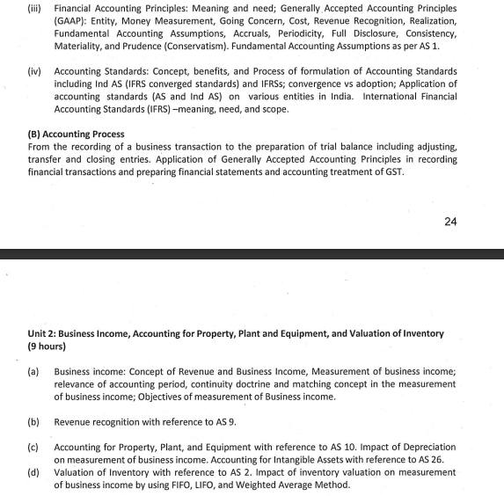
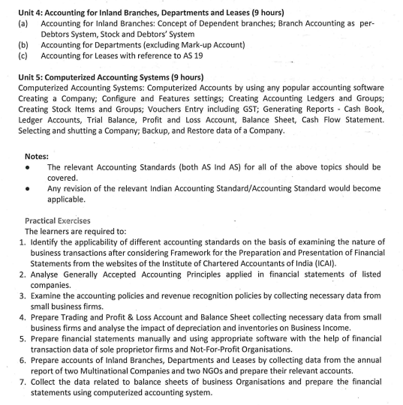
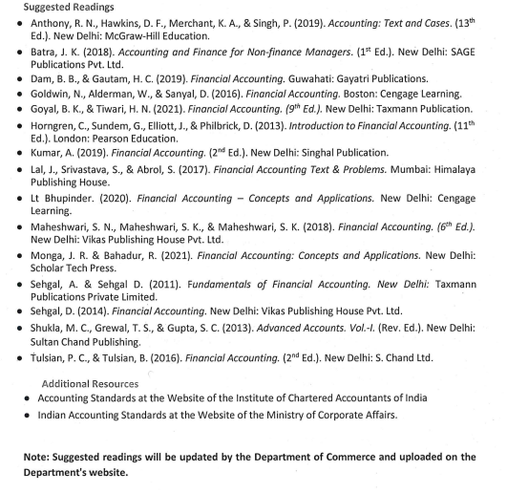

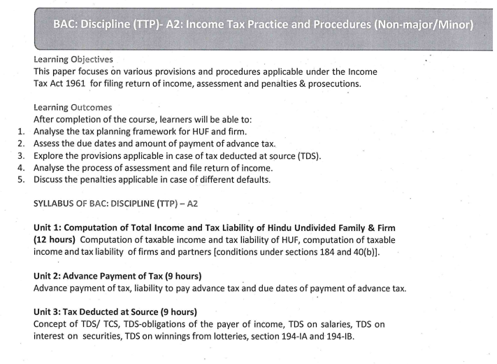
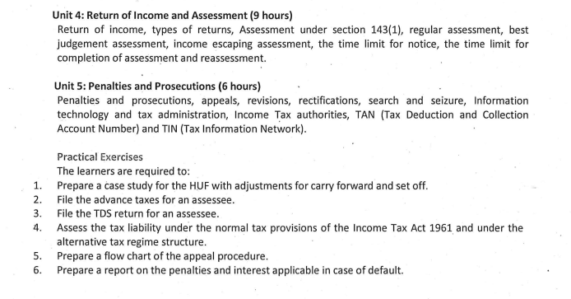
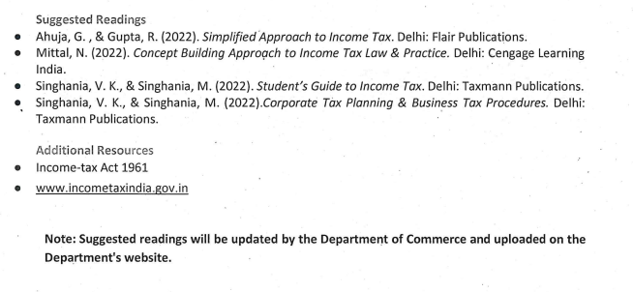

(Semester IV)

- BAC: Discipline (TTP) – A4: Fundamentals of Corporate Tax Planning (Non-Major/Minor)

Learning Objectives
This paper aims to provide basic knowledge of corporate tax in India and its effectiveness in tax planning.

Learning Outcomes
After completion of the course, learners will be able to:
1. Recognise the concept of tax planning, tax management and tax avoidance.
2. Interpret the application of minimum alternate tax.
3. Explore the benefits and incentives available to companies to start a new business.
4. Recognise the implications of tax provisions for a company with respect to capital
structure decisions
5. Identify the need for tax planning with respect to specific management decisions.

SYLLABUS OF BAC: Discipline (TTP) – A4
BAC: Discipline (TTP) – A4: Fundamentals of Corporate Tax Planning
(Non-Major/Minor)
224
Unit 1: Tax Planning Concepts and Types of Companies (5 hours)
Tax planning, tax management, tax evasion and tax avoidance; types of companies; residential
status of companies and tax incidence.
Unit 2: Assessment of Companies (13 hours)
Carry forward and set off of losses in case of certain companies; deductions available to
corporate assesses, Computation of total income and tax liability of companies and minimum
alternate tax.
Unit 3: Tax Planning with reference to setting up of a new business (9 hours)
Location of business; nature of business and form of ownership: firm/LLP vs company;
Unit 4: Tax Planning with reference to financial management decision (9 hours)
Tax planning with reference to capital structures and bonus shares.
Unit 5: Tax Planning with reference to specific management decisions (9 hours)
Tax planning with reference to purchase vs. lease of an asset and make vs. buy.

Exercises
The learners are required to:
1. Discuss case studies on tax evasion and tax avoidance.
2. Prepare a report for a hypothetical company which is non-resident in India and represent
the incidence of tax for the case.
3. Discuss provisions on minimum alternate tax as per the recent budget.
4. Specify the benefits available to a start-up company opting for operations in Northeast
India.
5. Develop a tax saving plan for a newly incorporated company for raising capital.
6. Prepare a case study indicating the impact of managerial decisions on the tax liability of
the company.
7. Compare the choice of a company to purchase a plant or to lease the same from a tax
savings point of view.

Suggested Readings
● Ahuja, G., & Gupta, R. (2019). Simplified approach to corporate tax planning &
management. Delhi, India: Wolters Kluwer India Pvt. Ltd.
● Singhania, V.K., & Singhania, M. (2022). Corporate tax planning & business tax
procedures. Delhi, India: Taxmann Publications.
Additional Resources
● Income-tax Act 1961
● www.incometaxindia.gov.in
Note: Suggested readings will be updated by the Department of Commerce and
uploaded on Department’s website.

- BAC: DSC-4: Principles of Management (Major)

Learning Objectives
The course aims to equip learners with essential management related knowledge and skills and
their applicability in the real world.

Learning Outcomes
After completion of the course, learners will be able to:
1. Discuss evolution of management and its significance.
2. Analyse applicability of managerial functions.
3. Assess the significance of planning and organising in business.
4. Interpret the role of directing in business.
5. Analyse the importance of controlling function and discuss contemporary issues in
management.

SYLLABUS OF BAC: DSC-4
Unit 1: Introduction to Management (9 hours)
Principles of management - concept, nature and significance; Evolution of Management
thought: Classical (Fayol’s principles of management; Taylor’s scientific management),
Neoclassical (Hawthorne Experiments), Modern approach (Systems Approach; Contingency
Approach).
Unit 2: Functions of Management (7 hours)
Management functions and their relationship- planning, organizing, staffing, directing and
controlling; Coordination - concept, characteristics and importance; Functional areas of
management – an overview.
Unit 3: Planning and Organizing (11 hours)
Planning- meaning, strategic and operations planning; Decision-making- concept, importance
and bounded rationality; Organizing- division of labor & specialization; Organisational
structures- traditional and modern; Factors affecting organisational design.
Unit 4: Directing (11 hours)
BAC: DSC-4: Principles of Management (Major)
210
Concept and theories of Motivation- Maslow’s need hierarchy, Herzber’s two-factor theory,
Theory X&Y; Leadership-meaning and importance, leadership styles, Transactional and
transformational leadership; Communication- meaning and importance.
Unit 5: Controlling and Contemporary Issues in Management (7 hours)
Principles of Controlling, performing controlling function; Management challenges of the 21st
Century; Century; Factors reshaping and redesigning management purpose, performance and
reward perceptions- Internationalization; Digitalization; Entrepreneurship & innovation;
Workplace Diversity

Exercises:
The learners are required to:
1. Assess the applicability of managerial theories in today’s corporate world.
2. Demonstrate the use of managerial functions in organizing an event.
3. Prepare a comparative analysis of organization structures of various companies.
4. Demonstrate various types of leadership styles in form of role play and identify the
motivation techniques used by leaders.
5. Discuss the impact of emerging issues in management.

Suggested Readings:
● Drucker, P. F. (1954). The Practice of management. New York, United States: Harper
& Row.
● Drucker, P. F. (1999). Management challenges for the 21st Century. New York, United
States: HarperCollins Publishers Inc.
● Griffin, R.W. (2011). Management principles and application. Massachusetts, Unites
States: Cengage.
● Koontz, H., & Weihrich, H. (2012). Essentials of management: An international and
leadership perspective. New York, United States: McGraw Hill Publications.
● Kumar, P. (2019). Management: principles and applications. Delhi: JSR Publication
House LLP.
● Laasch, O. (2022). Principles of management. California, United States: Sage
Textbook.
● Mahajan, J.P., Mahajan, A., & Dewan, D. (2017). Management principles and
applications. Uttar Pradesh, India: Vikas Publications.
● Rao, V.S.P. (2017). Management Principles and Applications. Delhi, India: Taxmann
Publications.
● Vasishth, N., & Rajput, N. (2016). Principles of management. Delhi: Kitab Mahal.
Note: Suggested readings will be updated by the Department of Commerce and uploaded
on Department’s website

(Semester VI)

- Discipline Specific Elective Paper 6(b): SEMESTER -VI
Indirect Taxes- Customs Act & Procedures

Duration: 3 Hrs. Marks: 100 Credits: 6
Course Objective
To enable an understanding of various provisions, documents and procedures under Customs law
Course Learning Outcomes
After completing the course, the student shall be able to:
CO1: know the basic concepts of customs act.
CO2: compute the assessable value for charging customs duty.
CO3: understand the meaning and procedures of import and export.
CO4: know the documentation related to customs duties.
CO5: understand export promotion schemes and importance of special economic zones
Course Contents
Unit I
Important terms and definitions under the Customs Act
Unit II
Types of duties; procedure to compute effective rate of duty
Unit III
Types of import - import of cargo, personal baggage and stores, courier and post
Unit IV
Clearance procedure including filing of relevant documents; Steps and documents to be
prepared; Penalties and prosecution
Unit V
Export promotion schemes; Duty drawback; EOU; Special Economic Zones
B.A. (Programme) - Commerce (CBCS) Department of Commerce, University of Delhi, Delhi
43
References
• Ahuja, Girish and Ravi Gupta. GST and Customs law. Flair Publications
• Singhania, Vinod K. GST and Customs law. Taxmann Publications Pvt. Ltd., New Delhi
Additional Resources
• Datey, V S , Customs law. Taxmann Publications Pvt. Ltd., New Delhi
• Rafi Mohammad , Indirect Taxes , Bharat Law house

- PAPER 6(a): SEMESTER –VI
Personal Selling & Salesmanship

Duration: 3 hrs. Marks: 100 Credits: 4
Course Objectives
B.A. (Programme) - Commerce (CBCS) Department of Commerce, University of Delhi, Delhi
182
The purpose of this course is to familiarize the students with the fundamentals of personal selling
and the selling process. They will be able to understand selling as a career and what it takes to be
a good salesperson. They will be able to learn the various theories of selling and motivation.
Course Learning Outcomes
After completing the course, the student will be able to:
CO1: explain the concepts of personal selling, roles and opportunities for sales persons.
CO2: understand the theories, models and approaches of selling.
CO3: comprehend the meaning of motivation in the context of personal selling.
CO4: describe the role of a salesperson in entire personal selling process in order to develop a
customer oriented attitude in selling.
CO5: learn various sales reports and ethical issue in selling.
Course Contents
Unit I: Introduction to Personal Selling
Nature and Importance of Personal Selling; Differences among Personal Selling, Salesmanship
and Sales Force Management; Role of Personal Selling in CRM; Qualities of a good salesperson;
Types of Selling Situations; Types of Salespersons; Career Opportunities in Selling; Measures for
making selling an attractive career.
Unit II: Theories of Selling
AIDAS Model of Selling; Problem Solving Approach; Right Set of Circumstances Theory and
Modern Sales Approaches.
Unit III: Buying Motives
Concept of Motivation; Maslow's Theory of Need Hierarchy; Buying Motives and their uses in
Personal Selling.
Unit IV: Personal Selling Process
Prospecting; Pre Approach; Approach; Presentation and Demonstration; Handling of Objections;
Closing the Sale; Follow-Up.
Unit V: Sales Planning and Control
Sales Reports and Documents; Various Ethical Issues in Selling.
References
B.A. (Programme) - Commerce (CBCS) Department of Commerce, University of Delhi, Delhi
183
• Buskirk, R. A. B. D. Buskirk, F. A. Russell (1988), Selling: Principles and Practices,
McGraw-Hill.
• Futrell, Charles (2013), Fundamentals of Selling, McGraw Hill Education.
• Kapoor, Neeru (2008), Advertising and Personal Selling, Pinnacle.
Note: Latest edition of the books should be used.
Additional Resources
• Castleberry, S.B. and Tanner, J. F. (2013), Selling: Building Relationships, McGraw Hill
Education.
• Belch, G. E., M. A. Belch and Purani K. (2009), Advertising and Promotion: An Integrated
Marketing Communications Perspective, McGraw Hill Education.

